

Se

Semester One Examination, 2013

Question/Answer Booklet

MATHEMATICS SPECIALIST 3A

Section Two:

Calculator-assumed

Student’s name solutions

Teacher : Mr White

Time allowed for this section
Reading time before commencing work: ten minutes
Working time for this section: one hundred minutes

Materials required/recommended for this section

To be provided by the supervisor
This Question/Answer Booklet
Formula Sheet (retained from Section One)

To be provided by the candidate
Standard items: pens, pencils, pencil sharpener, eraser, correction fluid/tape, ruler, highlighters

Special items: drawing instruments, templates, notes on two unfolded sheets of A4 paper, and up to three calculators satisfying the conditions set by the Curriculum Council for this examination.

Important note to candidates

No other items may be used in this section of the examination. It is your responsibility to ensure that you do not have any unauthorised notes or other items of a non-personal nature in the examination room. If you have any unauthorised material with you, hand it to the supervisor before reading any further.

Structure of this paper

Section | Number of questions available | Number of questions to be answered | Working time (minutes) | Marks available | Percentage of exam
Section One:  Calculator-free | 6 | 6 | 50 | 50 | 33
Section Two:  Calculator-assumed | 12 | 12 | 100 | 100 | 67
 |  |  | Total | 150 | 100

Instructions to candidates

- The rules for the conduct of Western Australian external examinations are detailed in the Year 12 Information Handbook 2013. Sitting this examination implies that you agree to abide by these rules.

- Write your answers in the spaces provided in this Question/Answer Booklet. Spare pages are included at the end of this booklet. They can be used for planning your responses and/or as additional space if required to continue an answer.
- Planning: If you use the spare pages for planning, indicate this clearly at the top of the page.
- Continuing an answer: If you need to use the space to continue an answer, indicate in the original answer space where the answer is continued, i.e. give the page number. Fill in the number of the question(s) that you are continuing to answer at the top of the page.

- Show all your working clearly. Your working should be in sufficient detail to allow your answers to be checked readily and for marks to be awarded for reasoning. Incorrect answers given without supporting reasoning cannot be allocated any marks. For any question or part question worth more than two marks, valid working or justification is required to receive full marks. If you repeat an answer to any question, ensure that you cancel the answer you do not wish to have marked.

- It is recommended that you do not use pencil, except in diagrams.

Section Two: Calculator-assumed (100 Marks)
This section has thirteen (13) questions. Answer all questions. Write your answers in the spaces provided.

Working time for this section is 100 minutes.

Question 7 (8 marks)
The graphs of the following four functions, where 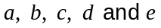 are positive constants, are shown on the axes below.
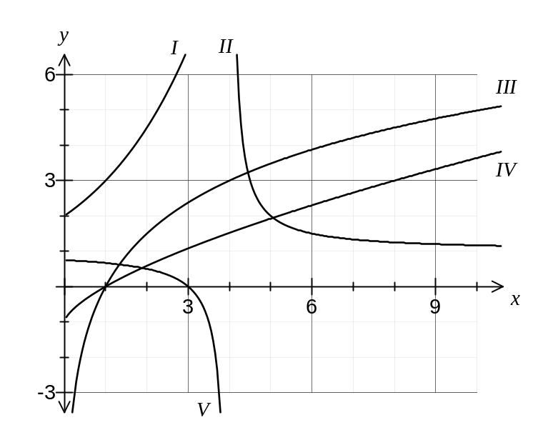
(a) Match appropriate sections of the graphs ( I, II, III, IV, V ) with their functions in the table below. (3 marks)

Function |  | 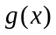 | 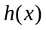 | 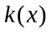
Section(s) | I | III | II, V | IV

(b) Determine the values of the positive constants . (5 marks)

Constant
Value | 3 |  | 2 | 4 | 1

Question 8 (12 marks)
Vectors and are as shown on the grid below.
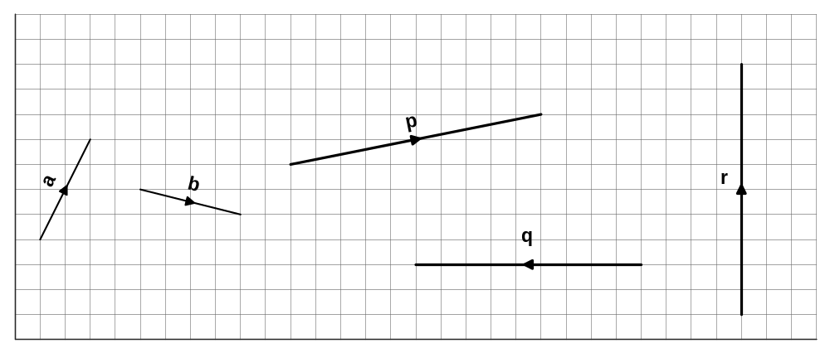

(a) On the grid above, sketch and label the vectors 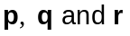 where

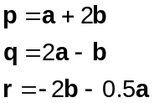
(7 marks)

(b) Two vectors have magnitudes of 45 N and 60 N and the angle between their directions is 130°. Sketch a diagram to show their sum and use trigonometry to calculate the magnitude of the resultant and the angle it makes with the smaller vector. (5 marks)
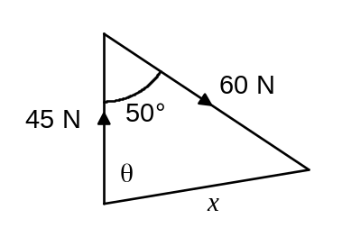

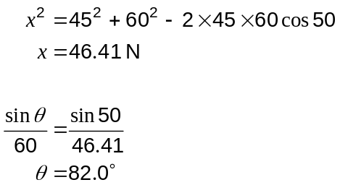

Question 9 (11 marks)
The latitude and longitude of three cities are given in this table, to the nearest degree.

City | Latitude | Longitude
Chicago (USA) | 42°N | 88°W
Luanda (Angola) | 9°S | 13°E
Rome (Italy) | 42°N | 13°E

Assume the radius of the earth is 6350 km. Calculate all distances to three significant figures and times to the nearest minute.

(a) Calculate the distance between Chicago and Rome along their common line of latitude.
(4 marks)
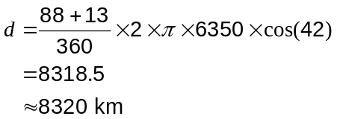

(b) A small plane leaves Rome to fly directly to Luanda at an average speed of 485 kilometres per hour. Ignoring the effects of altitude and any wind, determine

(i) how far the plane is from Luanda after seven hours. (3 marks)

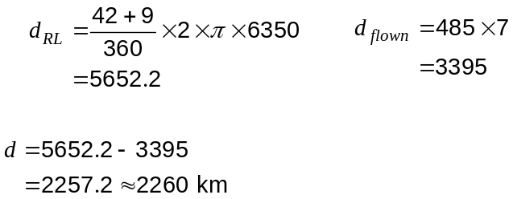

(ii) how long after leaving Rome the plane crosses the equator (line of latitude 0°N).
(2 marks)
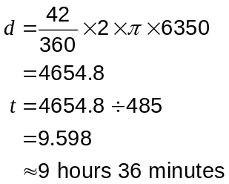

(iii) what time the plane reaches Luanda, if it left Rome at 7:30 am. (2 marks)
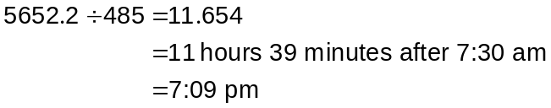

Question 10 (7 marks)
P and Q are two points directly across from each other on opposite banks of a river. P and Q are 60 m apart and a steady current flows along the river at 1.5 ms⁻¹.
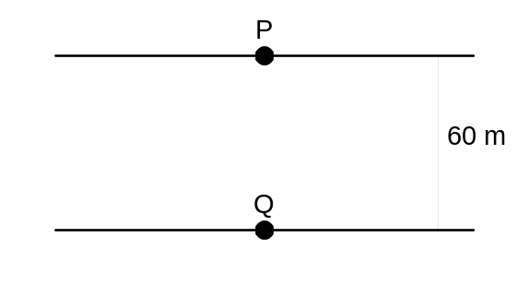
A boat with a speed of 2.8 ms⁻¹ must travel directly from P to Q. Find the angle the path of the boat must make with the river bank, to the nearest degree, and determine the time the boat will take, to the nearest tenth of a second.
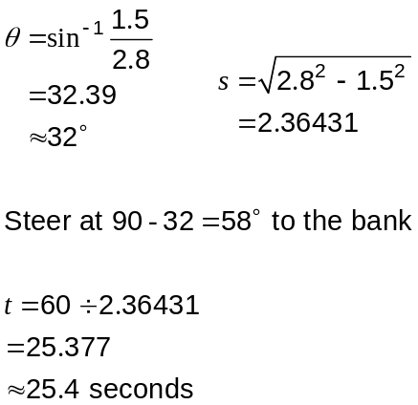

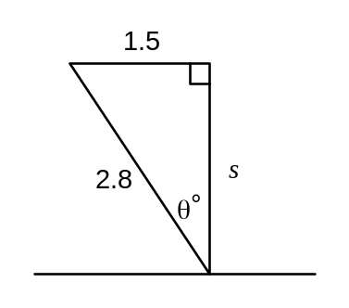

Question 11 (10 marks)
Two vectors are 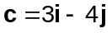 and 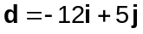.

(a) Find

(i) 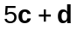 (2 marks)
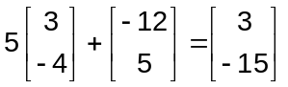

(ii) 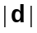 (2 marks)
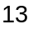

(iii) 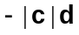 (2 marks)
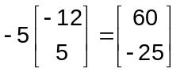

(b) Find and if 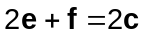 and 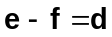. (4 marks)

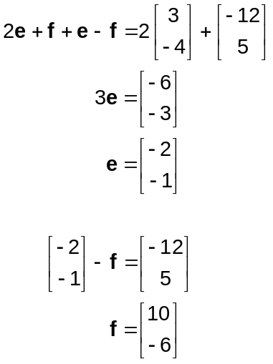

Question 12 (9 marks)
Let 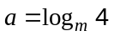 and 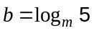.

(a) Write the following as a single logarithmic term.

(i) 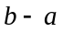 (1 mark)
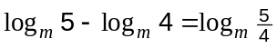

(ii) 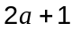 (2 marks)
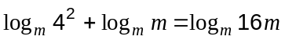

(b) Express the following in terms of and .

(i) 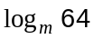 (1 mark)
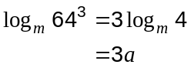

(ii) 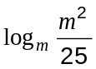 (2 marks)
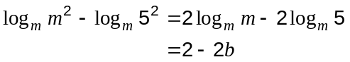

(iii) 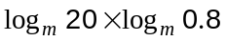 (3 marks)
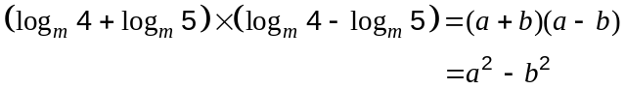

Question 13 (6 marks)
The Richter scale is used to measure the intensity of an earthquake.

, the magnitude of an earthquake on the Richter scale, is given by 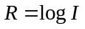, where is the intensity of the earthquake measured relative to the smallest seismic activity that can be measured. is usually rounded to one decimal place.

The location, year and magnitude of three large earthquakes are given in this table.

Earthquake | Meeberrie, 1979 | Sumatra, 2005 | Valdivia, 1960
,magnitude | 7.2 | 8.6 | 9.5

(a) Calculate the magnitude of the 1968 earthquake in Meckering, 130 km from Perth, which had an intensity of 7 940 000. (1 mark)
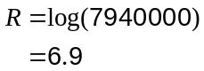

(b) What was the intensity of the 2005 earthquake in Sumatra, rounded to 3 significant figures? (2 marks)
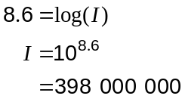

(c) The strongest earthquake ever recorded in the world was at Valdivia, Chile, in 1960. The strongest onshore earthquake ever recorded in Australia was at Meeberrie in 1979.

Express the ratio of the intensity of these two earthquakes in the form 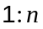, where 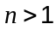.
(3 marks)
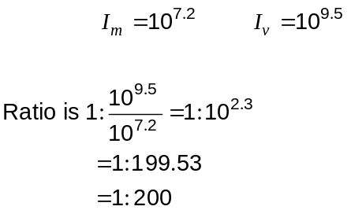

Question 14 (6 marks)
The points A, B and C have coordinates (4, 6), (10, -2) and (7, 10) respectively.

(a) Find the vector 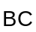. (1 mark)

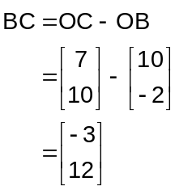

(b) Find 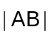 (2 marks)
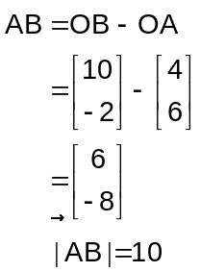

(c) The point D divides the line segment CB internally in the ratio 2:3.

Find the position vector of the point D. (3 marks)
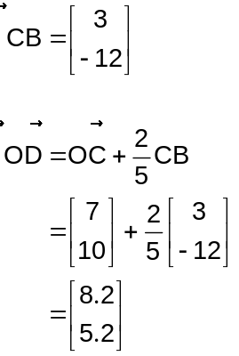

Question 15 (9 marks)
A helicopter hovering at a height of 130 m above level ground is sighted at the same instant from two points A and B. From A, the helicopter has a bearing of 335° and an angle of elevation of 18°. From B, 450 metres away from A, the bearing of the helicopter is 055°.

(a) Determine the bearing of A from B. (6 marks)

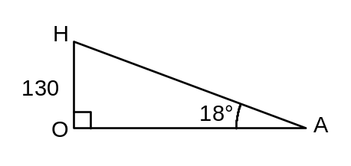

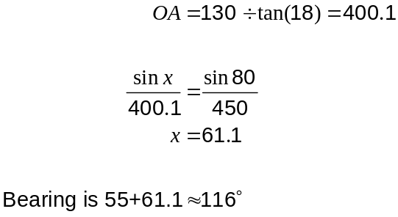

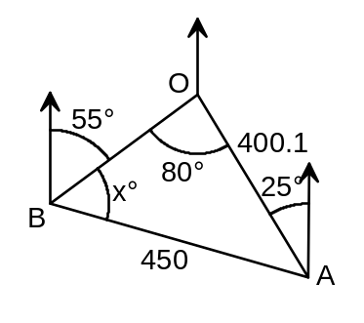

(b) Determine the angle of elevation of the helicopter from B. (3 marks)

From diagram 2:

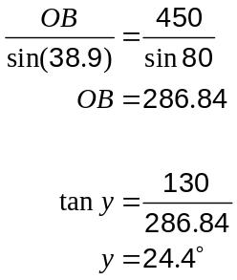

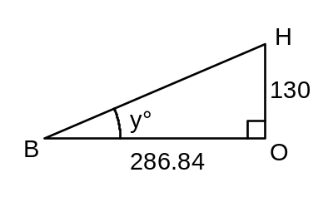

Question 16 (8 marks)
The internal temperature, °C, of a 200 gram potato placed into a hot oven is observed to change with time according to the rule 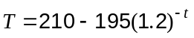, where is the time, in minutes, after being placed in the oven.

(a) Draw the graph of this relationship on the axes below. (3 marks)
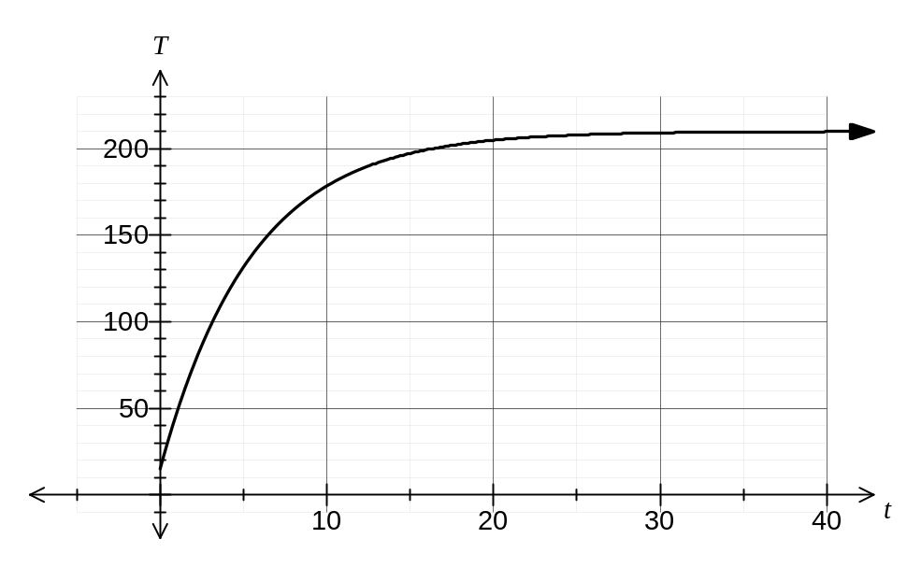

(b) What is the initial temperature of the potato? (1 mark)
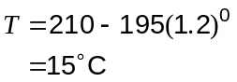

(c) Explain why the temperature of the potato can never exceed 210°C, according to this model. (1 mark)
As 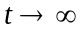, 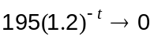 and so 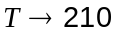°C

(d) How long, to the nearest minute, will it take for the temperature of the potato to increase from 100°C to 200°C? (3 marks)
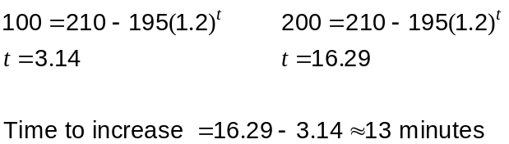

Question 17 (6 marks)
Two vectors are given by 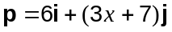 and 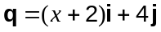.

(a) If 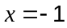, find a vector parallel to that has the same magnitude as . Give your answer in exact form. (3 marks)

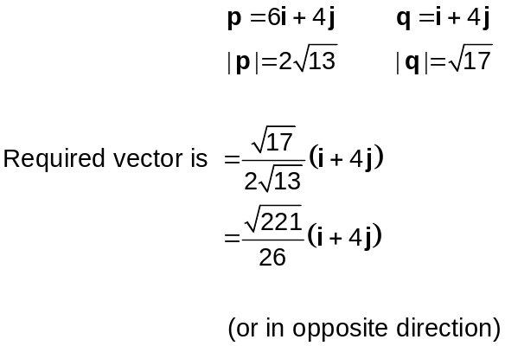

(b) Determine all possible values of so that and are parallel. (3 marks)
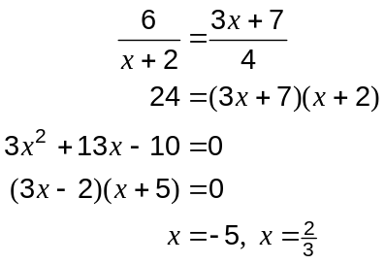

Question 18 (8 marks)
The cross-section of a plastic moulding is shown below. It is made from three circles, each of radius 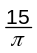 cm, that just touch each other.
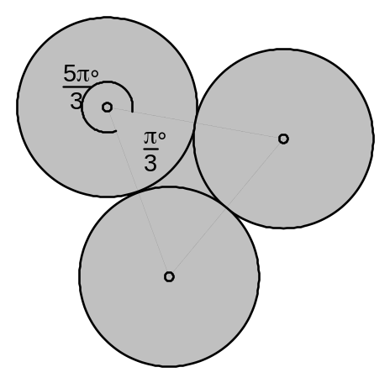

(a) Find the perimeter of the cross-section. (3 marks)

3 arcs subtending 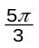

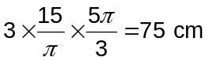

(b) Find the exact area of the cross-section. (5 marks)

3 sectors + 1 triangle (dotted):

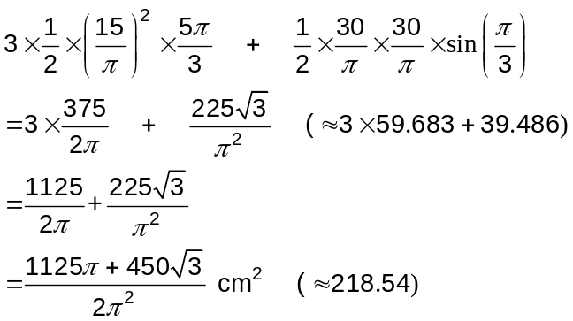

This examination paper may be freely copied, or communicated on an intranet, for non-commercial purposes within educational institutes that have purchased the paper from WA Examination Papers provided that WA Examination Papers is acknowledged as the copyright owner. Teachers within purchasing schools may change the paper provided that WA Examination Paper's moral rights are not infringed.

Copying or communication for any other purposes can only be done within the terms of the Copyright Act or with prior written permission of WA Examination papers.

Published by WA Examination Papers
PO Box 445 Claremont WA 6910

